Anti-Muslim India Gov’t. Razes Homes

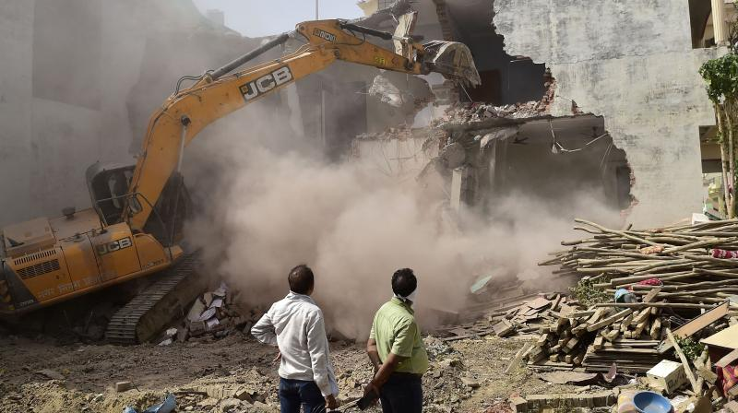
Photo: Still shot from video of Uttar Pradesh officials ordering demolition of Muslim citizens’ homes. Source: BBC.

Houses of Muslims demolished in Uttar Pradesh after protests
Authorities in the northern Indian state of Uttar Pradesh (UP) have demolished the houses of some Muslims who were allegedly linked to religious protests that turned violent.

The protests were sparked by derogatory remarks made by two former leaders of the governing Bharatiya Janata Party (BJP) about the Prophet Muhammad.

The demonstrations turned violent in some states as people damaged property.
More than 300 people were arrested in UP.

Local authorities demolished three Muslim-owned houses over the weekend, alleging that they had been illegally constructed - a claim denied by some of the owners.

The demolitions triggered condemnation from opposition leaders, who accused the state government - headed by chief minister Yogi Adityanath - of targeting the minority Muslim community.

Critics say religious polarisation has deepened in India since 2014, when the Hindu nationalist BJP came to power. Hate speech and attacks against Muslims have risen sharply over the past few years.

A tweet from Mrityunjay Kumar, Mr Adityanath's media adviser, also sparked outrage.

He had tweeted a photo of a bulldozer demolishing a building, adding: "Unruly elements remember, every Friday is followed by a Saturday."

Two of the destroyed houses belonged to people who were accused of throwing stones after Friday prayers.

The third was that of a politician named Javed Ahmed, who has been accused of planning the protests. His daughter, Afreen Fatima, is a prominent Muslim rights activist who had participated in the protests against a controversial citizenship law.

A former chief justice of the Allahabad high court told The Indian Express newspaper that the demolition of Mr Ahmed's house was "totally illegal".

"Even if you assume for a moment that the construction was illegal, which by the way is how crores of Indians live, it is impermissible that you demolish a house on a Sunday when the residents are in custody," former Chief Justice Govind Mathur said.

An official from the Prayagraj Development Authority (PDA) - which demolished Mr Ahmed's house - has said it had issued a notice to him in May, asking him to appear before them. But Ms Fatima has denied this, saying the family was only informed when a notice was stuck to their door on Saturday.

A group of lawyers also wrote to the high court, pointing out that the demolition was against the law.

"No earlier notices of illegal construction were received by the accused or his wife," their letter said.

This is not the first time Uttar Pradesh and some other BJP-ruled states have been accused of using demolitions to target alleged protesters in the aftermath of communal violence. Experts have questioned the method's legal sanction.

"You are disproportionately punishing people of one community without following any due process. This is not just illegal, but it also sets a dangerous precedent," Ashhar Warsi, a senior lawyer, had told the BBC in April.

In the meantime, the controversy over the comments made by the former BJP leaders shows no signs of dying down.

It was triggered by a remark made by former BJP spokesperson Nupur Sharma in a televised debate last month. Videos of her statement went viral, sparking sporadic protests.

Naveen Jindal, who was media head of the party's Delhi unit, had also posted a provocative tweet on the issue.

The issue gained global attention after more than a dozen countries from the Islamic world condemned the remarks, sparking a diplomatic nightmare for India.

The BJP then suspended Ms Sharma and expelled Mr Jindal. Ms Sharma and her family have also been given protection by the Delhi Police after she said she received harassment and threats.

But Ms Sharma has received support from many BJP supporters online. Some of her party colleagues also tweeted in her support after the recent protests against her remark took a violent turn.

A YouTuber from Indian-administered Kashmir was arrested after he posted a video that showed him beheading an effigy of Ms Sharma. In Jharkhand state, two people died of bullet injuries during the protests.

Original article

Photo: Still shot from video of Uttar Pradesh officials ordering demolition of Muslim citizens’ homes. Source: BBC.

Watch: Officials ordered the demolition of houses of Muslims accused of prompting violence

India Copies Israeli Home-razing Tactics

Omar Ahmed, Middle East Montior

13 June 2022

Demolishing Muslim protestors' homes: India is taking a leaf out of Israel's book

Over the weekend Indian authorities bulldozed several homes belonging to Muslims in the northern state of Uttar Pradesh (UP). The homeowners were alleged to have taken part in organised protests on Friday in response to inflammatory remarks about the Prophet Muhammad (peace be upon him) made by the now ousted spokesperson for the country's ruling-Hindu hardline BJP party. It is the latest provocation against India's sizeable Muslim population, following a high-court decision in March in the southern Karnataka state to ban women wearing the hijab in schools and colleges.
The Indian government was forced to distance itself from the comments amid a diplomatic storm between New Delhi and several Muslim majority countries, including Iran and strategic partners in the Gulf. However, on the ground the damage had already been done, as popular anger gave way to demonstrations by India's significant but marginalised Muslim minority.
Among those whose houses were razed to the ground was a young Muslim activist Afreen Fatima who is the daughter of Javed Mohammad, an activist himself associated with the Welfare Party of India, a political party launched by the Muslim organisation, Jamaat-e Islami Hind.
Indian police accuse her father of being one of the main organisers of the protests which erupted in the UP city of Prayagraj (formerly Allahabad but renamed in 2018 in line with Hindu nationalist sentiments) while many ended peacefully, some soon turned violent and tensions arose between Muslims and Hindus, spreading to other parts of the country. Hundreds have since been arrested and police forces shot dead at least two Muslim protestors in the eastern city of Ranchi in a bid to disperse the protestors.
READ: Massive rallies held in India over insults to Prophet Muhammad
The decision to demolish homes of people associated with the protests was ordered by the chief minister of UP, Yogi Adityanath, who justified the actions claiming the properties were illegal establishments. Since the order, three demolitions have taken place in two days – the properties of two people were razed after they were accused of stone throwing. The firebrand Hindu monk and politician who belongs to Prime Minister Narendra Modi's BJP party has since vowed to continue with "bulldozer action".
As footage of the demolitions fast became viral on social media, observers and critics were quick to point out the stark parallels with long-standing policies implemented by Israeli occupation forces against the homes of Palestinians, ordinary citizens, protestors and resistance members alike. Just last year it was estimated that Israeli forces demolished 937 structures, displacing nearly 1,200 people.
Senior Congress leader Shashi Tharoor reacting to Afreen Fatima's house being demolished yesterday questioned whether the local government had exempted itself from the country's Constitution. The Thiruvananthapuram MP tweeted: "Due process of law is fundamental to democracy. Under what law and following what process has this been done? Has UP exempted itself from the Constitution of India?"
While a worrying development, razing people's homes are expected as Israel and India forged strong ties in recent years, with both countries governed by religious-nationalist ideologies (Zionism and Hindutva, respectively) with both facing accusations of apartheid policies, in fact these charges date back as far as 2002, when Modi was chief minister for Gujarat, when the state witnessed some of the worst anti-Muslim violence in decades. These comparisons are all the more compelling when both countries pride themselves on their supposed trademarked democratic values – Israel "the only democracy in the Middle East" and India being "the largest democracy in the world".
OPINION: The Prophet of Islam gives Muslim rulers a lesson on strength in unity
It has become evident that Modi's government is taking a leaf out of Israel's book when it comes to the practise of destroying homes, ironically citing "illegal settlements" and "security concerns". India's recent disproportionate activities over mere stone-throwing in two cases, is also reflective of similar Israeli actions. Only last week, an Israeli lawmaker drafted a draft law seeking to double the punishment for throwing stones to four years and last year the Israeli military's rules of engagement were revised to formally permit the opening of fire against Palestinians who throw stones, even as they flee.
Even the case of bulldozing illegal settlements raises fundamental rights issues and concerns over due process. The Indian Express noted yesterday in a report that "In many cases, notices are issued but the demolition is timed with a protest and a particular section is targeted giving the subject no time to appeal."
Former Allahabad High Court Chief Justice Govind Mathur was quoted in the report as saying: "This is totally illegal. Even if you assume for a moment that the construction was illegal, which by the way is how crores of Indians live, it is impermissible that you demolish a house on a Sunday when the residents are in custody. It is not a technical issue but a question of rule of law."
The recent razing of houses belonging to India's Muslim minority is a dangerous precedent and illustrative of the direction the country is heading, following Israel's lead. However, the practise itself is not unprecedented, as in April authorities in New Delhi bulldozed a number of "illegal" Muslim-owned businesses, requiring the Supreme Court to step in and halt further destruction. Following this incident, Pranay Somayajula, an advocacy and outreach coordinator for the US-based Hindus for Human Rights, opined last month that "The fact that bulldozers have cropped up in both India and Israel as a chilling symbol of state repression is no coincidence."
India's continued adherence and emulation of Israel's apartheid policies against a significant and politically-inconvenient minority, is further proof that neither country is the secular, value-based democracy it claims to be.

Original article

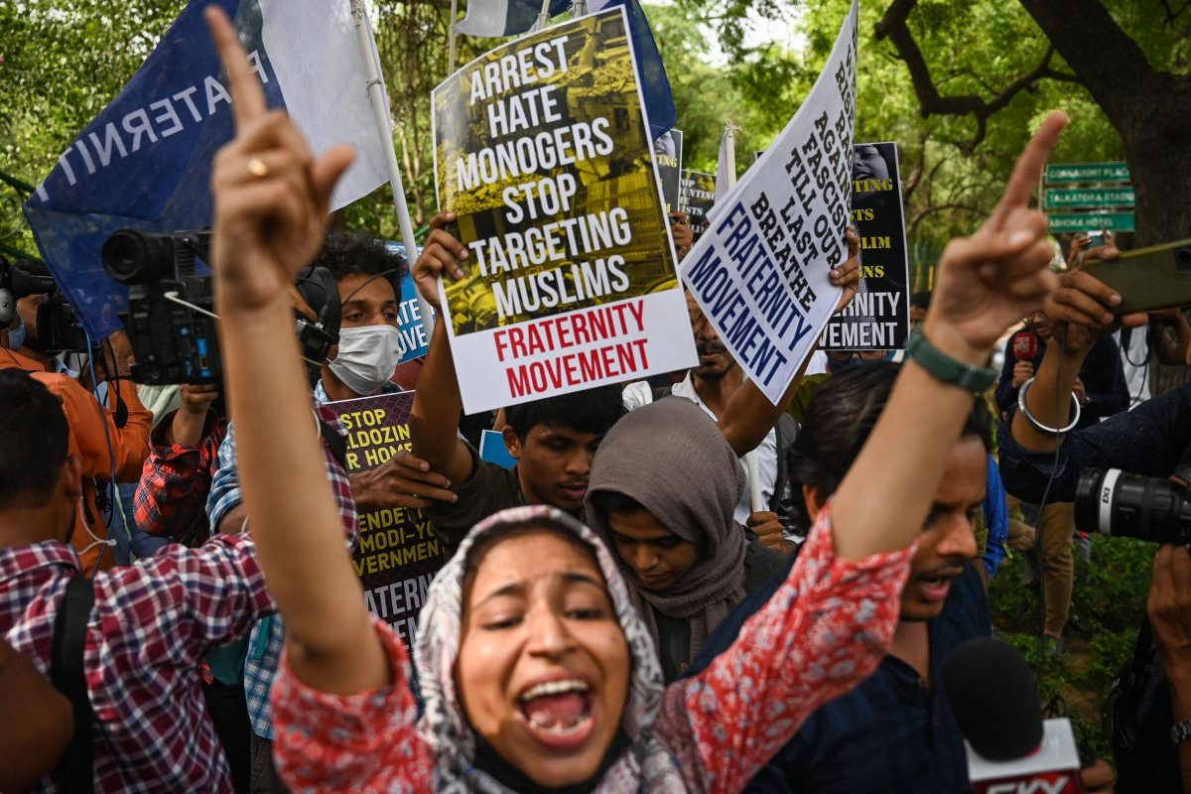
Photo: Students display placards and shout slogans during a demonstration outside the Uttar Pradesh Bhawan in New Delhi on 13 June 2022, to protest against the state government for demolishing the house of a local Muslim leader in Allahabad. Source: Money Sharma/AFP via Getty Images.

