Evicted Retired Munali Teachers Demand for Payment of their dues by the Government.
August 19, 2019
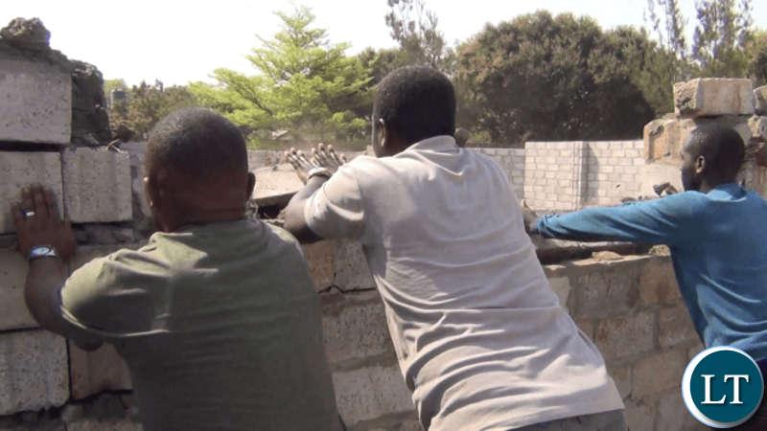Zambia Police and Council Workers Demolishing the Houses of retired Munali Secondary School teachers
The retired Munali Secondary School teachers who were last week evicted from government houses by council police have demanded for payment of their dues by the government.
The evicted teachers have also accused Lusaka Province Minister Bowman Lusambo of being behind the demolition of their structures leaving them in the cold.
The visibly angry retirees of whom some have continued to spend nights in the cold said Mr Lusambo is a ruthless and heartless leader who does not care about the plight of the poor.
They said they are ready to leave once paid their money as stipulated in the laws of Zambia.
“We are ready to vacate these premises, it’s not like we want to be here. All we are waiting for is our money”, they said.
Others talked to expressed disappointment that two weeks after being given the eviction letters, the council police appeared in drunken state midnight forcing them out of the houses.
They said they are agrieved because they are not there illegally as they are waiting for their dues which government has faiked to pay on time.
Recently, government issued an eviction notice to over 20 retirees living in teachers houses at Munali Secondary school.
The eviction notices also stated that the structures such as shops, boarding houses, chicken runs and garages within the premises should be demolished within a week.

https://www.lusakatimes.com/2019/08/19/evicted-retired-munali-teachers-demand-for-payment-of-their-dues-by-the-government/

