Syrdario Region, Uzbekistan – Some dams last a thousand years. But Sardoba collapsed on May 1 after just three years, its mighty waters washing away villages of more than 35,000 hectares (86,486 acres) of land in Uzbekistan and Kazakhstan.

Maria and her family escaped in the last moment before the waves took their home and everything they owned.

“We have lost everything. Nothing was spared. I stayed with one dress,” says the 65-year old, her voice trembling and tears running down her fatigued face.

She is standing behind a fence of a school building in Kurgantepa, the Sirdaryo region, a place her family and more than 200 others now call home.

“They have been sending us from one place to another. We are tired. I don’t even know whom I can ask for help. Nobody visits us to check how we live. The food is bad, it’s cold and we don’t have enough clothes,” she says.

“How can they do this to us? Some rooms are shared by two families. It wasn’t like this even during wartime. They are harrowing the nation.”

Six people lost their lives and 100,000 were temporarily displaced in both Uzbekistan and Kazakhstan as a result of the disaster.

Despite the scope of the tragedy, for the past four months, local officials have prevented journalists from investigating victims’ claims of mistreatment, and the causes of the disaster.

Several local reporters say they have faced intimidation and threats while working on the story and at least one of them has lost her job.

Anora Sodykova, who worked for the state-run Uza.uz news agency, travelled to Sardoba and heard officials warned residents against speaking to the media. When she returned to Tashkent, she posted on Facebook about what she had witnessed. Soon after, she was fired.

‘They gave us only thin mattresses, we are freezing at night’

In front of Kurgantepa’s school building, a group of policemen keep guard.

None of the displaced residents can leave the premises. The guards claim it is a quarantine facility and not a temporary home for survivors. But they cannot stop people gathered in front of the gate from speaking up.

“They gave us only thin mattresses, we are freezing at night. Our children have no clothes and they don’t go to school. I don’t know what to do,” says Asal, a pensioner.

“I’m here with my whole family, 16 people in total. We used to have a big house. Now, the government has promised to give me an apartment, but my children will receive nothing.”

According to an official government website, as of late July, more than 16,000 people still lived in temporary accommodation, including more than 2,000 in public buildings such as schools.

Most of the displaced will receive new accommodation from the government.

Many have also received financial compensation to be able to survive. But it is still unclear how long they will have to stay in provisional accommodation.

The residents of Babur were lucky – their homes survived the flood. The government warned them in advance and they left in time before the water flooded their homes, orchards and cattle.

They returned a week later to a new reality. Their homes were damaged, water was still floating on the sleepy streets and the stifling stench of latrines spread to the furthest corners of the village.

Gulmurod Khokimov, a 70-year-old pensioner, and his family of 14 inspect the damages in their large home and back yard.

Their animals survived but most of the walls cracked; the water had severely damaged the house’s foundation.

But a visit from an official responsible for assessing the damages gave them hope. He said those who need help in rebuilding their homes will receive an equivalent of $4,000.

It soon turned out, however, many of the villagers will never see the promised funds.

According to residents, only those neighbours with connections and those who were willing to pay high bribes to the local commission have managed to rebuild their homes.

“We are tired. I don’t believe the officials any more,” says Khokimov surrounded by a dozen of neighbours sharing his fate. “Nobody in our household has a job. We usually work in the fields, but this year the flood destroyed all crops. My pension is all we have. My wife is ill. Life is hard. We only buy bread.”

One of the residents claims she received a phone call from a local official who promised her compensation if this material was not published.

President Shavkat Mirziyoyev called a commission to investigate the circumstances of the disaster, which included those responsible for constructing the dam, such as Deputy Prime Minister Achilbay Ramatov and Senator Abdugani Sanginov.

In 2019, Uzbekistan ranked 153rd out of 180 in Transparency International’s corruption perception index.

While there is no direct evidence proving corruption in the construction of the Sardoba dam, experts believe it is no coincidence it collapsed after only three years.

“There is no information in open sources on how contracts for the construction of the Sardoba reservoir were distributed. Secondly, the atmosphere of impunity for corruption prevails in the country,” says Alisher Ilkhamov, research associate at SOAS, University of London.

“We do not know yet whether all these violations were the result of kickbacks for obtaining lucrative contracts, which is why the budget did not have funds left for strict observance of standards, design and construction norms. A number of signs, however, raise the suspicion that the practice of kickbacks flourished here, as is the case with many similar projects, especially in the construction sector.”

By the time of publishing, government officials had not responded to Al Jazeera’s request for comment.

The preliminary results of an official investigation suggest irregularities in the design, construction and operation of the dam. According to official sources, nine people have been arrested so far.

Meanwhile, Khokimov and his neighbours back in Babur are preparing for a bleak winter.

“We cannot afford to repair the houses ourselves. No one has a job,” he says. “We are afraid of what will happen in winter. Our house is collapsing. It is dangerous to live here.”

Original article

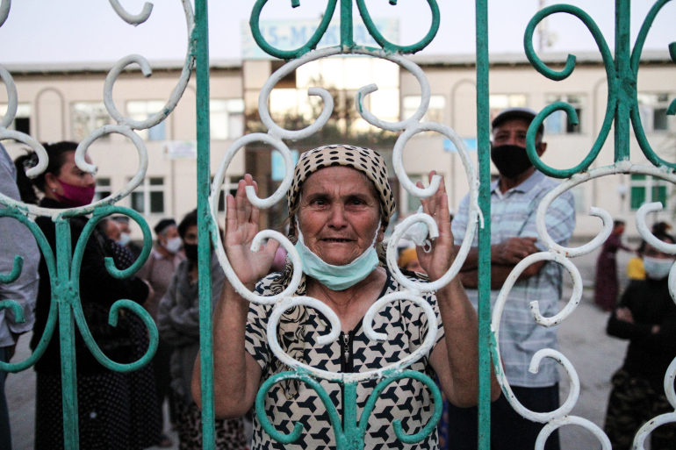
Photo: Maria and other residents stand behind a school gate where they are taking shelter following the flood [Agnieszka Pikulicka-Wilczewska/Al Jazeera]

